# **Product Allocation for Warehouse:**

## Steps for allocating the items if goods bought is not equal to the total amount

1. Calculate the ratio of increment or decrement between total and bought.
2. Multiply the order of each store by the ratio.
3. Adjust the value obtained in step two to the closest multiple of the MOQ.
4. The values obtained in step 3 are the allocation values.
5. Return the access (if any).

Example:

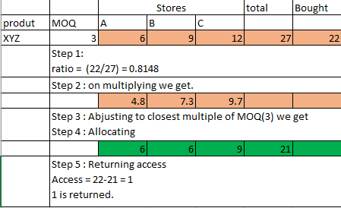

## Flowchart:

